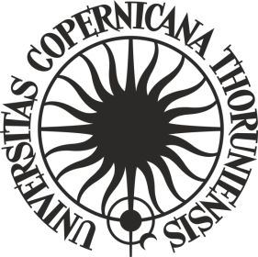

**ORDER No. 239**

**by the Rector of Nicolaus Copernicus University in Toruń**

of 19 December 2024

**amending Order No. 216 by the Rector of Nicolaus Copernicus University in Toruń of 8 October 2020. Rules of the call for post-doctoral interns outgoing to foreign centres under the “Excellence Initiative – Research University” programme**

Pursuant to art. 52.3 of Resolution No. 37 of the Senate of Nicolaus Copernicus University in Toruń of 16 April 2019 - the Statutes of Nicolaus Copernicus University in Toruń (NCU Legal Bulletin of 2024, item 10) in connection with order No. 225 of the NCU Rector of 16 November 2021 - Regulations for the organisation and management of the "Excellence Initiative - Research University" programme at Nicolaus Copernicus University in Toruń (NCU Legal Bulletin of 2021, item 374 as amended)

**i t i s o r d e r e d** as follows:

Article 1

In Order No.216 by the Rector of Nicolaus Copernicus University in Toruń of 8 October 2020. Rules of the call for post-doctoral interns outgoing to foreign centres under the “Excellence Initiative – Research University” programme (Legal Bulletin of 2020, item 354 as amended), Article 6.1 shall read as follows:

**“1. The trip shall end within 6 months of obtaining the financial resources for its implementation. Exceeding the deadline referred to in the first sentence shall result in the loss of funding in proportion to the period of exceedance.”**.

Article 2

The order becomes effective as of 19 December 2024.

**R E C T O R**

**Prof. dr hab. Andrzej Tretyn**