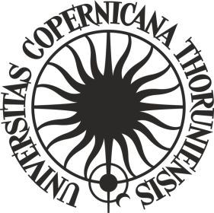

**ORDER No. 241**

**by the Rector of Nicolaus Copernicus University in Toruń**

of 19 December 2024

**amending Order No. 125 by the Rector of Nicolaus Copernicus University in Toruń of 17 August 2022 Regulations of the competition for the mobility of doctoral students at the Nicolaus Copernicus University in Toruń**

Pursuant to art. 52.3 of Resolution No. 37 of the Senate of Nicolaus Copernicus University in Toruń of 16 April 2019 - the Statutes of Nicolaus Copernicus University in Toruń (NCU Legal Bulletin of 2024, item 10) in connection with order No. 225 of the NCU Rector of 16 November 2021 - Regulations for the organisation and management of the "Excellence Initiative - Research University" programme at Nicolaus Copernicus University in Toruń (NCU Legal Bulletin of 2021, item 374 as amended)

**i t i s o r d e r e d** as follows:

Article 1

In Order No. 125 by the Rector of the Nicolaus Copernicus University in Toruń of 17 August 2022 Regulations of the competition for the mobility of doctoral students at the Nicolaus Copernicus University in Toruń (Legal Bulletin of 2022, item 219), Article 5.2 shall read as follows:

**“2. The trip shall be carried out within 6 months of the announcement of the list of laureates.”.**

Article 2

The order becomes effective as of 19 December 2024.

**R E C T O R**

**Prof. dr hab. Andrzej Tretyn**