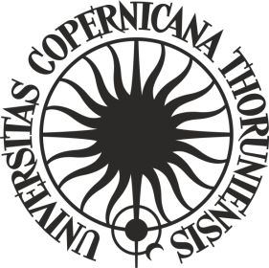

**ORDER No. 243**

**by the Rector of Nicolaus Copernicus University in Toruń**

of 19 December 2024

**amending Order No. 156 by the Rector of Nicolaus Copernicus University in Toruń of 19 July 2023 Regulations of the student mobility competition at Nicolaus Copernicus University in Toruń Student Mobility for InternationAl CoopeRaTion: SMART2**

Pursuant to art. 52.3 of Resolution No. 37 of the Senate of the Nicolaus Copernicus University in Toruń of 16 April 2019 - the Statutes of the Nicolaus Copernicus University in Toruń (NCU Legal Bulletin of 2024, item 10) in connection with order No. 225 of the NCU Rector of 16 November 2021 - Regulations for the organisation and management of the "Excellence Initiative - Research University" programme at Nicolaus Copernicus University in Toruń (NCU Legal Bulletin of 2021, item 374 as amended)

**i t i s o r d e r e d** as follows:

Article 1

In Order No. 156 by the Rector of Nicolaus Copernicus University in Toruń of 19 July 2023 Regulations of the student mobility competition at Nicolaus Copernicus University in Toruń Student Mobility for InternationAl CoopeRaTion: SMART2(NCU Legal Bulletin of 2023, item 270), Article 4.6 shall read as follows:

**“6. The trip which is the subject of the application shall begin no later than within 6 months from the date of announcement of the decision of the competition committee.”.**

Article 2

The order becomes effective as of 19 December 2024.

**R E C T O R**

**Prof. dr hab. Andrzej Tretyn**