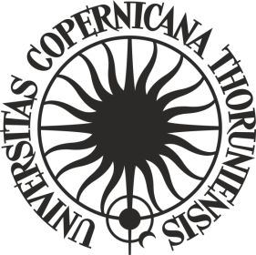

**ORDER No. 245**

**by the Rector of Nicolaus Copernicus University in Toruń**

of 19 December 2024

**amending** **Order No. 141 by the Rector of Nicolaus Copernicus University in Toruń of 28 June 2023 Regulations of the competition for doctoral students’ training at Nicolaus Copernicus University in Toruń**

Pursuant to art. 52.3 of Resolution No. 37 of the Senate of Nicolaus Copernicus University in Toruń of 16 April 2019 - the Statutes of Nicolaus Copernicus University in Toruń (NCU Legal Bulletin of 2024, item 10) in connection with order No. 225 of the NCU Rector of 16 November 2021 - Regulations for the organisation and management of the "Excellence Initiative - Research University" programme at Nicolaus Copernicus University in Toruń (NCU Legal Bulletin of 2021, item 374 as amended)

**i t i s o r d e r e d** as follows:

Article 1

Order No. 141 by the Rector of Nicolaus Copernicus University in Toruń of 28 June 2023 Regulations of the competition for doctoral students’ training at Nicolaus Copernicus University in Toruń (NCU Legal Bulletin of 2023, item 246) shall be amended as follows:

1. Article 3 shall read as follows:

**„Article 3**

**An application for the competition may concern training, the planned start date of which is no earlier than one month after the application is submitted, and the end date no later than 6 months after the application is submitted”;**

1. the following point (4) shall be added in Article 6 :

**"4. The funds should be used by 31/10/2025."**

Article 2

The order becomes effective as of 19 December 2024.

**R E C T O R**

**Prof. dr hab. Andrzej Tretyn**