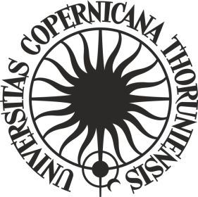**ORDER No. 250**

**by the Rector of Nicolaus Copernicus University in Toruń**

of 23 December 2024

**amending Order No. 21 by the Rector of Nicolaus Copernicus University in Toruń of 10 February 2022 Regulations of the “Grants4NCUStudents” competition for research tasks and travels abroad implemented by students and doctoral students of Nicolaus Copernicus University in Toruń**

Pursuant to art. 52.3 of Resolution No. 37 of the Senate of Nicolaus Copernicus University in Toruń of 16 April 2019 - the Statutes of Nicolaus Copernicus University in Toruń (NCU Legal Bulletin of 2024, item 10) in connection with order No. 225 of the NCU Rector of 16 November 2021 - Regulations for the organisation and management of the "Excellence Initiative - Research University" programme at Nicolaus Copernicus University in Toruń (NCU Legal Bulletin of 2021, item 374 as amended)

**i t i s o r d e r e d** as follows:

Article 1

Order No. 21 by the Rector of Nicolaus Copernicus University in Toruń of 10 February 2022 Regulations of the “Grants4NCUStudents” competition for research tasks and travels abroad implemented by students and doctoral students of Nicolaus Copernicus University in Toruń (NCU Legal Bulletin of 2022, item 43) shall be amended as follows:

1. the following point (4) shall be added in Article 2:

**"4. It is permissible to organize a competition only for one of the two initiatives indicated in art.2.1 (projects or trips).";**

2) Article 6.1.shall read as follows:

**"1. The deadline for the implementation of the project or trip shall be 6 months from the moment of obtaining authorization to dispose of financial resources for its implementation. The scientific supervisors of the project shall be authorized to dispose of the project funds.".**

Article 2

The order becomes effective as of 23 December 2024.

**R E C T O R**

**Prof. dr hab. Andrzej Tretyn**